What is base image is not correct?

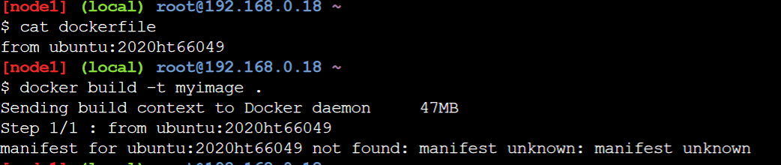

what is -y not given?

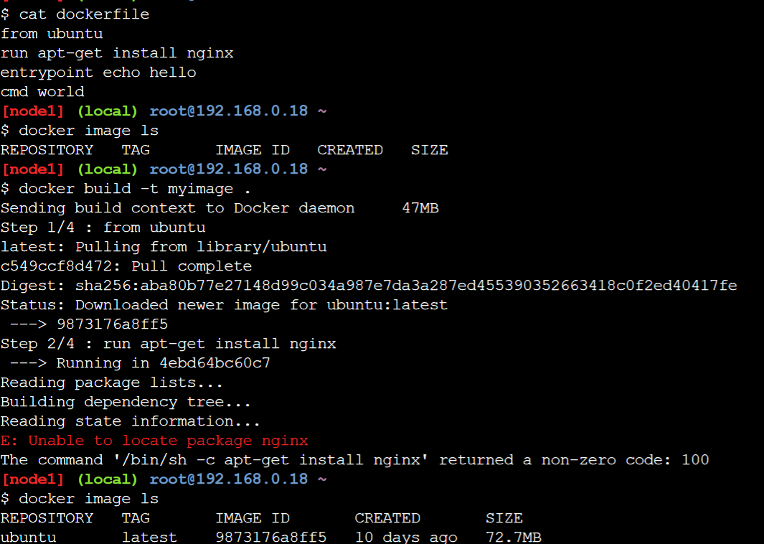



CMD would be ignored if entry point specified correctly.

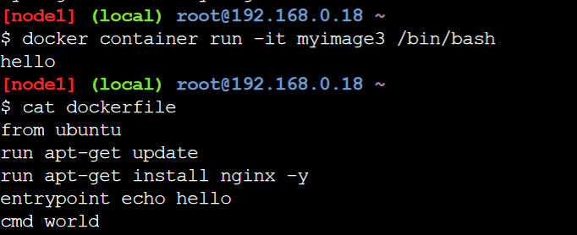

Combination of run/echo and entrypoint.

